**The Garbage Collector – The Game – Part 3**

***algorithm help***

if ( r and c are in bounds and [r][c] is true )

mark spot to false

4 recursive calls up down left right

**Lab Goal :** This lab was designed to teach you more about recursion.

**Lab Description :** Remove all of the trash from the streets. The orange cells filled green are the parts of the city that have trash and the empty orange cells are clean parts of the city. A block or area of trash is any continuous group of filled green cells connected either horizontal or vertical to another adjacent filled green cell. Once you select a piece of trash ( a green cell with orange border ), pick it up and all other pieces of trash that are touching it up, down, left, or right.

**Sample Output :**

**This trash block**

**contains two cells.**

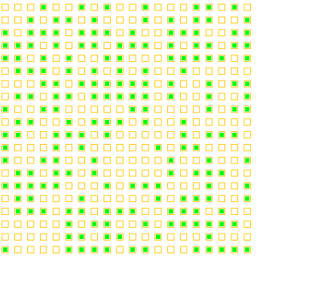

**This trash block**

**contains four cells.**

You will click your mouse on the trash you wish to pick up and the trash will disappear. All trash touching the clicked cell ( up, down, left, or right ) will be removed along with the cell you clicked.

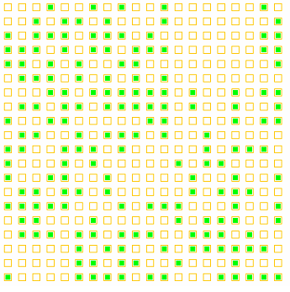

**The trash has been picked up.**

**Files Needed ::**

**Locatable.java**

**Cell.java**

**ColoredCell.java**

**Grid.java**

**GarbageCollector.java**

**GraphicsRunner.java**

BONUS ::

As you remove the trash, change each cell to blue so that you can follow the path of the recursion around as it moves around the screen.

You will need to add a Graphics parameter to the pickUpTrash() method so that you can draw on the screen as you pick up the trash.